HOW TO DOWNLOAD FONTS
- Download the font files. These often come compressed in .zip folders. In one .zip folder, you might find several variations on the same font, such as “light” and “heavy.”
- The font files are zipped, unzip them by right-clicking the .zip folder and then clicking Extract. Now you'll see the available font files:
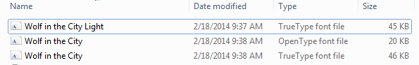
- Right-click the fonts you want, and click Install.
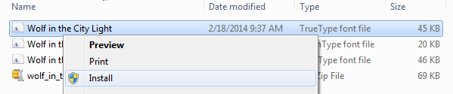
- If you're prompted to allow the program to make changes to your computer, click Yes.
Your new fonts will appear in the fonts list.
Here are two other ways to install and manage fonts:
- All fonts are stored in the C:\Windows\Fonts folder. Optionally, you can add fonts by simply dragging font files from the extracted files folder into this folder. Windows will then automatically install them. To see what a font looks like, open the Fonts folder, right-click the font file, then select Preview.
- You can also see your installed fonts via the Control Panel. Depending on you version of Windows, you will go to either Control Panel > Fonts --or-- Control Panel > Appearance and Personalization > Fonts.

